******DAYANANDA SAGAR COLLEGE OF ENGINEERING**

(An Autonomous Institute affiliated to VTU, Belagavi, Approved by AICTE & ISO 9001:2008 Certified)

Accredited by National Assessment & Accreditation Council (NAAC) with ‘A’ grade, Shavige Malleshwara Hills, Kumaraswamy Layout, Bengaluru-560078.

**Minor Project Report**

**on**

**“Designing and Implementing Wide Area Network Using OSPF Protocol”**

Submitted By

Ritik Raj (1DS20CS169)

Rithik Raj Pandey (1DS20CS168)

**Fifth Semester B.E (CSE)**

**in**

**Computer Networks Laboratory**

**19CS5DLCNL**

Under the guidance of

**Dr. Nagaraja J.**

**Associate Professor**

**Dept. of CSE**

**DSCE, Bangalore**

| **S. No.** | **Contents** | **Page** |
| --- | --- | --- |
|  |  | 1 |
| 1 | Introduction |  |
| 2 | Design | 2 |
| 3  4 | Configuration    Topology | 3    4 |
| 5 | Real time and Simulation Mode Results | 5,6 |
| 6 | Conclusion and Future Enhancement | 7 |

**Abstract :**

This project deals with the design and simulation of a Wide Area Network and a topology which consists of 10 networks. After that, Implement the scenario using OSPF Protocol (multi Area Concept).

The project consists of 10 different networks with class-C IP Addresses starting from (198.100.1.0 - 198.100.1.144). This Consists of a Wide Area Network for data communication that operates beyond the geographic scope of a Local Area Network We have used DHCP, Web and DNS server in the network. In this, OSPF (Open Shortest Path First) Protocol is used to find the best path between the source and the destination through a link.

OSPF is a link state routing protocol that uses a database of the network’s topology to determine the best route for data packets to take from their source to their destination.

**Introduction :**

This Project includes a Wide Area Network of 10 different networks. These network consists of PCs, Web Server, DNS and DHCP Servers. The OSPF(Open Shortest Path First) is used for routing the network to find the best path between the source and the destination. To find the best path, We have configured all the routers according to OSPF configuration. We have also subnetted the IP Address 198.100.0.0 to 10 different networks. The area in the network carried out by OSPF routing works well, so that the information dissemination becomes faster and more efficient.

* A Wide Area Network is a data communication network that operates beyond the geographic scope of a Local Area Network.
* Dynamic routing is a process where a router can forward data via a different route for a given destination based on the current conditions of the communication circuits within a system.
* OSPFis a link state routing protocol that is used to find the best path between the source and the destination

**Design :**

For 10 networks, we have to borrow 4 bits from the Host.

Old Subnet Mask: 255.255.255.0

New Subnet Mask: 11111111.11111111.11111111.11110000

255.255.255.240

| **Network Address** | **Usable Host Range** | **Broadcast Address** |
| --- | --- | --- |
| 198.100.1.0 | 198.100.1.1-198.100.1.14 | 198.100.1.15 |
| 198.100.1.16 | 198.100.1.17-198.100.1.30 | 198.100.1.31 |
| 198.100.1.32 | 198.100.1.33-198.100.1.46 | 198.100.1.47 |
| 198.100.1.48 | 198.100.1.49-198.100.1.62 | 198.100.1.63 |
| 198.100.1.64 | 198.100.1.65-198.100.1.78 | 198.100.1.79 |
| 198.100.1.80 | 198.100.1.81-198.100.1.94 | 198.100.1.95 |
| 198.100.1.96 | 198.100.1.97-198.100.1.110 | 198.100.1.111 |
| 198.100.1.112 | 198.100.1.113-198.100.1.126 | 198.100.1.127 |
| 198.100.1.128 | 198.100.1.129-198.100.1.142 | 198.100.1.143 |
| 198.100.1.144 | 198.100.1.145-198.100.1.174 | 198.100.1.159 |

**OSPF Configuration:**

Router 0 :

Router(config)#route ospf 1

Router(config-router)#network 198.100.1.0 0.0.0.15 area 0

Router(config-router)#network 198.100.1.80 0.0.0.15 area 0

Router(config-router)#network 198.100.1.144 0.0.0.15 area 0

Router(config-router)#exit

Router 1 :

Router(config)#route ospf 1

Router(config-router)#network 198.100.1.48 0.0.0.15 area 0

Router(config-router)#network 198.100.1.80 0.0.0.15 area 0

Router(config-router)#network 198.100.1.144 0.0.0.15 area 0

Router(config-router)#exit

Router 2 :

Router(config)#route ospf 1

Router(config-router)#network 198.100.1.32 0.0.0.15 area 0

Router(config-router)#network 198.100.1.112 0.0.0.15 area 0

Router(config-router)#network 198.100.1.96 0.0.0.15 area 0

Router(config-router)#exit

Router 3 :

Router(config)#route ospf 1

Router(config-router)#network 198.100.1.16 0.0.0.15 area 0

Router(config-router)#network 198.100.1.112 0.0.0.15 area 0

Router(config-router)#network 198.100.1.128 0.0.0.15 area 0

Router(config-router)#exit

Router 4 :

Router(config)#route ospf 1

Router(config-router)#network 198.100.1.128 0.0.0.15 area 0

Router(config-router)#network 198.100.1.64 0.0.0.15 area 0

Router(config-router)#network 198.100.1.144 0.0.0.15 area 0

Router(config-router)#exit

**Topology:**

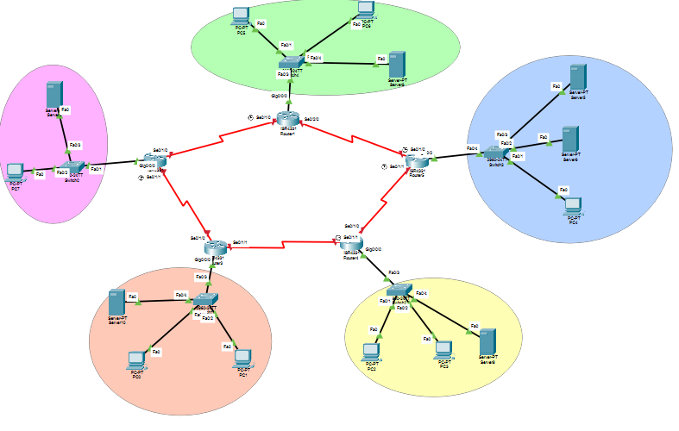

**OSPF:**

Open Shortest Path First (OSPF) is a routing protocol that is used to find the shortest path for data to travel from one network to another. It is used in Internet Protocol (IP) networks and is a link-state protocol, which means that it stores information about the entire network and all its components in a database, and then uses this information to calculate the shortest path to a destination.

OSPF is a widely used routing protocol in large enterprise networks and is also used in some service provider networks. It is known for its fast convergence, which means that it can quickly adjust to changes in the network, such as the addition or removal of a device or link. OSPF can also support multiple equal-cost paths to a destination, allowing for load balancing redundancy.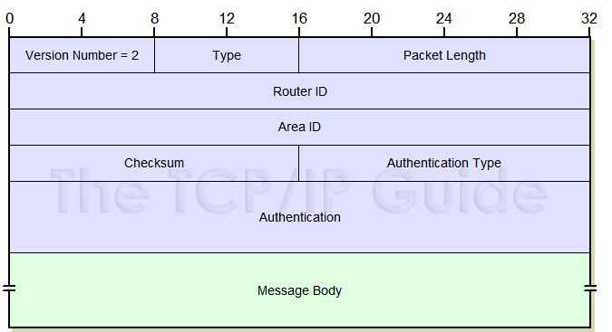

fig : OSPF header

The OSPF header is the part of an OSPF packet that contains information about the packet itself, such as its type, length, and checksum. The OSPF header consists of several fields, each of which has a specific purpose. The fields in the OSPF header are:

Version: This field indicates the version of the OSPF protocol being used.

Type: This field specifies the type of OSPF packet, such as a hello message, a database description message, or a link-state request message.

Packet length: This field specifies the length of the OSPF packet, including the header and any additional data.

Router ID: This field contains the unique identifier of the router that originated the packet.

Area ID: This field specifies the area to which the packet belongs.

Checksum: This field contains a checksum value that is used to verify the integrity of the packet.

Autonomous System (AS) number: This field specifies the AS to which the packet belongs.

Authentication: This field is used to authenticate the packet and ensure that it was not tampered with.

The OSPF header is followed by additional data, depending on the type of OSPF packet. For example, a hello message might contain information about the state of the link.

**Real time and Simulation Mode Results :**

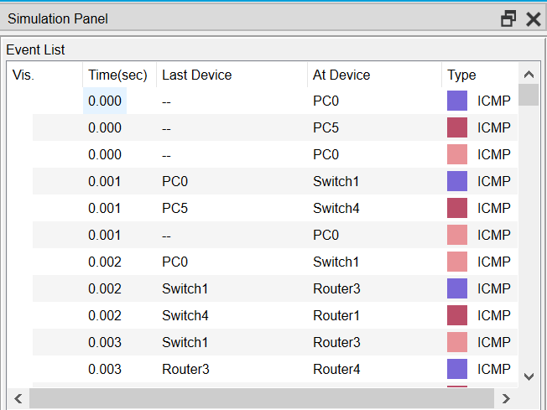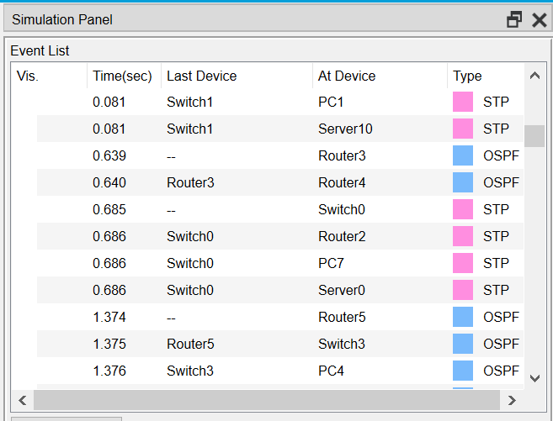

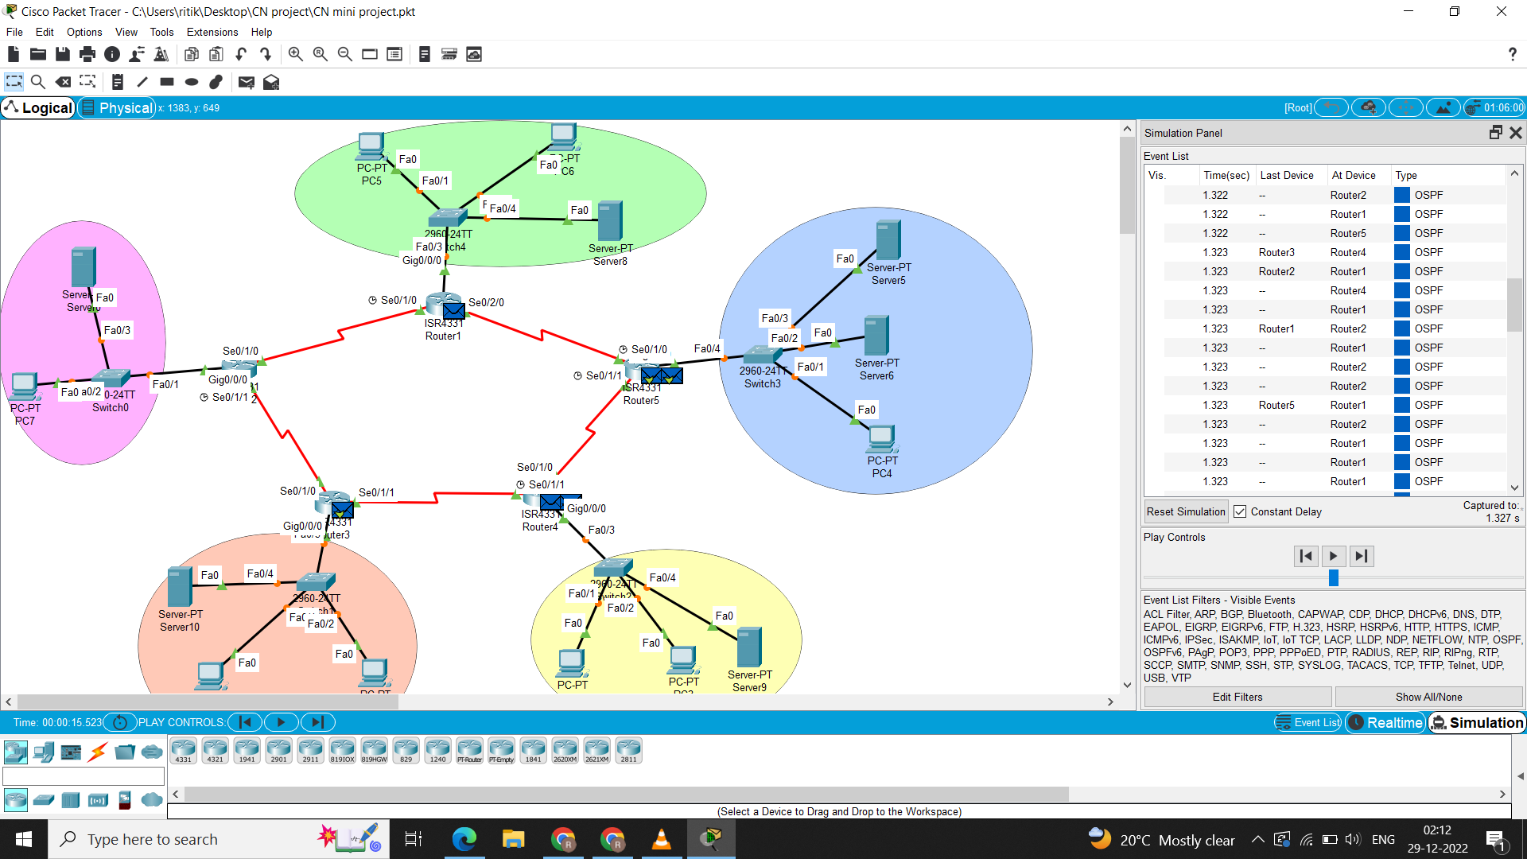

**Conclusion and Future Enhancement:**

In conclusion, the design and implementation of a wide area network (WAN) using the OSPF protocol are as follows :-

* Provide a reliable and efficient method for interconnecting devices and networks over a large geographical area.
* OSPF is a link-state routing protocol that uses a database of the network's topology to determine the best route for data packets to take from their source to their destination.
* It can be used to route traffic over various types of WAN connections, such as leased lines, satellite links, and broadband internet.

There are several potential areas for future enhancement in the design and implementation of a Wide Area Network (WAN) using the OSPF (Open Shortest Path First) protocol. Some of these enhancements will be:-

* Improved scalability: As the size and complexity of a WAN grows, it is important to ensure that the OSPF routing protocol can scale to meet these demands.
* Enhanced security: This could involve adding encryption and authentication to OSPF messages, as well as implementing other security measures such as access control lists and firewalls.
* Improved reliability: This could involve implementing features such as fast convergence and multipath routing to improve the reliability of the network.
* Advanced routing features: OSPF is a powerful routing protocol that supports a wide range of features and capabilities.
* Integration with other technologies: WANs are often integrated with other technologies, such as virtual private networks (VPNs) and cloud computing platforms.